Written Assessment

Mobile Optimisation

IT6035 Mobile Development

Name: Vitor Antunes Cazella

Student ID: 91050051

# Task 1: Mobile Optimisation Overview

With the number of mobile devices being as dominant as it is now-a-days, websites have to expect a great part of its users to be accessing through these devices, and this is when the term Mobile Optimisation comes into play.

What is a mobile optimised website?

A mobile-optimised website refers to optimising a website specifically for mobile users from which navigate, read and use it differently from the desktop users.

What are its benefits?

Mobile-optimised websites have great upsides for users and website owners since well optimised websites tend to keep users for longer using it and they are more likely to recommend it to others, this way increasing the number of users. Also for users the positive side of using a well optimised website is somewhat obvious, having less delay and being responsive makes it a good experience.

What are the challenges of implementing optimization?

Having an optimised website requires great planning and good cooperative work. Developing software for mobile comes with some limitations that usually are not there on desktop computers, having to deal with smaller devices, ergo less processing power and smaller screens.

So, when creating a website now-a-days, mobile optimisation is practically mandatory therefore you should think of methods you can use to make the most of your resources to give the user the best experience possible.

# Task 2: Mobile Optimisation Examples

How to recognise that a website is mobile optimised?

The biggest sign of performance success is when nobody notices how well it is performing.

A site is mobile friendly when it...

* presents content well on a phone
* does not need pinching / zooming
* is easily readable on small screens
* is easy to navigate with a finger
* is helpful to someone using a phone

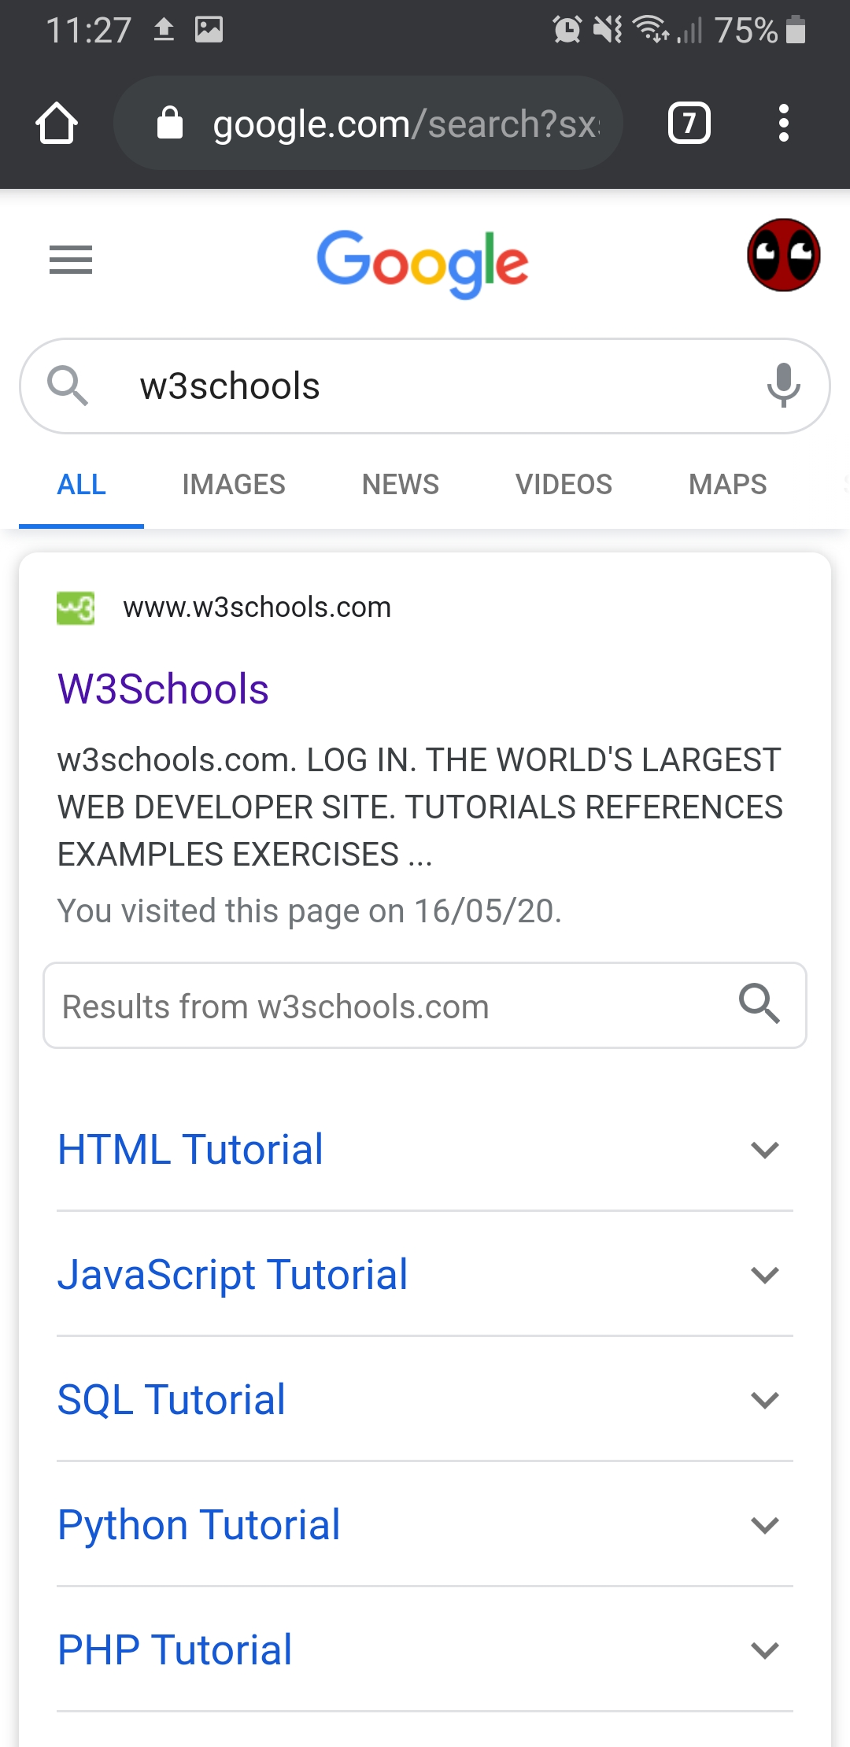

Two of many examples that I found were Google and GitHub as presented above, websites very mobile friendly in aspects of content adaptation for smaller screens, being able to use every feature the website has to offer even on your phone.

# Task 3: Design and Analysis of Specific Case

When developing a website intended to mobile devices its design will be prepared for mobile usability, which we already determined is different from mouse and keyboard users, having to deal with the touchscreen.Now when it comes to already existing websites that were fully developed for desktop computers can be a bit more complicated to be converted to a mobile version.

The biggest risk when creating a mobile app based on an original site is that using the same content, page files may be too big and therefore take much longer to load in devices that are more likely to have unstable connectivity.

Things you should look for when creating a mobile app based on an website:

* Choose a mobile method
* Update the website code
* Verify mobile friendliness
* Make sure that Google understand your website
* Optimize

## Optimisation methods that will apply for the Specific Case:

### **Improve Server Response Time**

As said by Google, for an efficient website to work smoothly your server response time should be under 200ms. Therefore this is an optimisation goal important to achieve to have a good website user experience.

Another way is to reduce the resources a page uses, like css, javascript, etc. So, if the company doesn’t want to reduce image quality it will have to work on these other kinds of files to make it faster to load.

### **Leverage Browser Caching**

This method like the one above should help with images to load faster, browser caching stores the page resource files on a local computer when the user first visits a web page. What it does is "remember" the resources that the browser has already loaded. When a visitor goes to another page on your website your logo, CSS files, etc. do not need to be loaded again. That reduces loading times and saves connectivity resources.

### **Critical Render Path**

Understanding how a web page is rendered can help us understand how to make it do it more efficiently. So, using a critical rendering path can make a large webpage with many resources load faster than a small webpage with few resources.

There are certain types of resources that our webpages call that actually block the render of our webpages. The two most common are the CSS files and the javascript files.

There are really just three things to concentrate on..

* Minimize the number of critical resources.
* Minimize the number of critical bytes.
* Minimize the critical path length.